Curriculum Map of Medical Ignorance
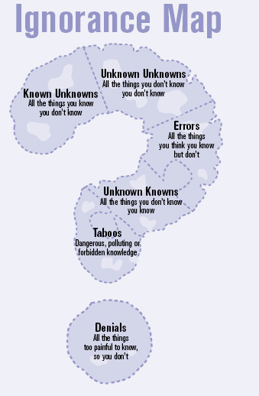

Source: The University of Arizona

